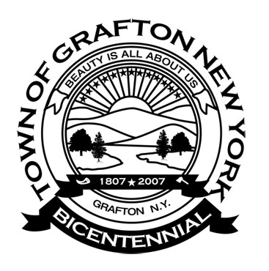
Agenda
Grafton Town Board
Regular Meeting
June 25, 2018 – 7:00PM

Pledge of Allegiance
Call to Order / Roll Call
Approval/Correction of Minutes:
From Town Board Meeting May 28, 2018

Reports and Remittances from Town Committees
Assessor Report
Budget & Finance
Buildings/Code Enforcement
Buildings & Grounds Committee
Town Clerk’s Report
Dog Control Officer Report
Highway
Library
Rescue Squad
Senior Citizen Representative
State Park
Supervisor
Veterans & Seniors
Youth Report

Communications Received

Old Business

Public Comment (Privilege of the Floor)
(Reminder: Public comment is limited to 5 minutes per person)
Be mindful the Public Comment portion of the meeting is a privilege. All comments and statements shall be directed to the Town Board. Please refrain from any personal attacks, name calling or derogatory public comments toward individuals.
New Business
Cemetery upkeep for Summer

Motions & Resolutions

Motion to Pay All Bills as Audited
Vouchers # - $

Adjournment in Loving Memory of:

