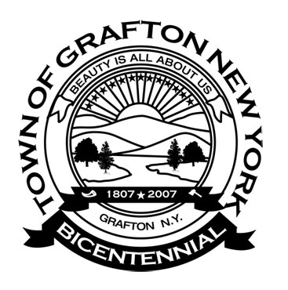
Agenda
Grafton Town Board
Regular Meeting
September 10, 2018 – 7:00PM

Pledge of Allegiance
Call to Order / Roll Call
Approval/Correction of Minutes:
From Town Board Meeting August 13, 2018

Reports and Remittances from Town Committees
Assessor Report
Budget & Finance
Buildings/Code Enforcement
Buildings & Grounds Committee
Town Clerk’s Report
Dog Control Officer Report
Highway
Library
Rescue Squad
Senior Citizen Representative
State Park
Supervisor
Veterans & Seniors
Youth Report

Communications Received

Old Business

Public Comment (Privilege of the Floor)
(Reminder: Public comment is limited to 5 minutes per person)
Be mindful the Public Comment portion of the meeting is a privilege. All comments and statements shall be directed to the Town Board. Please refrain from any personal attacks, name calling or derogatory public comments toward individuals.
New Business

Motions & Resolutions

Motion to Pay All Bills as Audited
Vouchers # - $

Adjournment in Loving Memory of:

